**Practical 12 : Create basic ToDo notes application which allows user to add / view / update /**

**delete todo notes. Use Room database library for data persistence.**

**Activity_main.xml**

*<?*xml version="1.0" encoding="utf-8"*?>*<RelativeLayout xmlns:android="http://schemas.android.com/apk/res/android"  
 xmlns:app="http://schemas.android.com/apk/res-auto"  
 xmlns:tools="http://schemas.android.com/tools"  
 android:layout_width="match_parent"  
 android:layout_height="match_parent"  
 android:padding="20dp"  
 android:layout_gravity="center"  
 android:gravity="center"  
 tools:context=".MainActivity">  
  
 <Button  
 android:id="@+id/insertButton"  
 android:layout_width="match_parent"  
 android:layout_height="wrap_content"  
 android:text="Create a to do list"/>  
  
 <Button  
 android:id="@+id/viewButton"  
 android:layout_width="match_parent"  
 android:layout_height="wrap_content"  
 android:text="View a to do list"  
 android:layout_below="@id/insertButton"/>  
  
 <Button  
 android:id="@+id/modifyButton"  
 android:layout_width="match_parent"  
 android:layout_height="wrap_content"  
 android:text="Modify a to do list"  
 android:layout_below="@id/viewButton"/>  
  
</RelativeLayout>

**Activity_insert.xml**

*<?*xml version="1.0" encoding="utf-8"*?>*<LinearLayout xmlns:android="http://schemas.android.com/apk/res/android"  
 android:orientation="vertical"  
 android:layout_width="match_parent"  
 android:layout_height="match_parent"  
 android:padding="20dp">  
  
 <EditText  
 android:id="@+id/titleEditText"  
 android:layout_width="match_parent"  
 android:layout_height="wrap_content"  
 android:hint="Enter a title"/>  
  
 <EditText  
 android:id="@+id/taskEditText"  
 android:layout_width="match_parent"  
 android:layout_height="wrap_content"  
 android:hint="Enter a task"/>  
  
 <Button  
 android:id="@+id/roomInsertButton"  
 android:layout_width="wrap_content"  
 android:layout_height="wrap_content"  
 android:text="Submit Data"  
 android:layout_gravity="center_horizontal"/>  
  
</LinearLayout>

**Activity_view.xml**

*<?*xml version="1.0" encoding="utf-8"*?>*<FrameLayout  
 xmlns:android="http://schemas.android.com/apk/res/android"  
 android:layout_width="match_parent"  
 android:layout_height="match_parent">  
  
 <android.support.v7.widget.RecyclerView  
 android:id="@+id/viewToDoListRecyclerView"  
 android:layout_width="match_parent"  
 android:layout_height="match_parent">  
  
 </android.support.v7.widget.RecyclerView>  
  
</FrameLayout>

**View_list.xml**

*<?*xml version="1.0" encoding="utf-8"*?>*<LinearLayout  
 xmlns:android="http://schemas.android.com/apk/res/android"  
 android:layout_width="match_parent"  
 android:layout_height="match_parent"  
 android:orientation="vertical"  
 android:padding="20dp">  
  
 <TextView  
 android:id="@+id/titleTextView"  
 android:layout_width="match_parent"  
 android:layout_height="wrap_content" />  
  
 <TextView  
 android:id="@+id/taskTextView"  
 android:layout_width="match_parent"  
 android:layout_height="wrap_content" />  
  
</LinearLayout>

**Activity_modify.xml**

*<?*xml version="1.0" encoding="utf-8"*?>*<LinearLayout xmlns:android="http://schemas.android.com/apk/res/android"  
 android:orientation="vertical"  
 android:layout_width="match_parent"  
 android:layout_height="match_parent"  
 android:padding="20dp">  
  
 <EditText  
 android:id="@+id/titleEditText"  
 android:layout_width="match_parent"  
 android:layout_height="wrap_content"  
 android:hint="Enter title to be modified"  
 android:layout_marginTop="15sp"/>  
  
 <EditText  
 android:id="@+id/taskEditText"  
 android:layout_width="match_parent"  
 android:layout_height="wrap_content"  
 android:layout_marginTop="15sp"/>  
  
 <Button  
 android:id="@+id/updateTaskButton"  
 android:layout_width="wrap_content"  
 android:layout_height="wrap_content"  
 android:layout_gravity="center_horizontal"  
 android:text="Update"  
 android:layout_marginTop="15sp"/>  
  
 <Button  
 android:id="@+id/deleteTaskButton"  
 android:layout_width="wrap_content"  
 android:layout_height="wrap_content"  
 android:layout_gravity="center_horizontal"  
 android:text="Delete"  
 android:layout_marginTop="15sp"/>  
</LinearLayout>

**ToDList.java**

package list.todo.com.todolist;  
import android.arch.persistence.room.Entity;  
import android.arch.persistence.room.PrimaryKey;  
  
@Entity(tableName = "todolist")  
public class ToDoList {  
 @PrimaryKey(autoGenerate = true)  
 private int _id;  
  
 private String title;  
 private String task;  
  
 public int get_id() {  
 return _id;  
 }  
  
 public void set_id(int _id) {  
 this._id = _id;  
 }  
  
 public String getTitle() {  
 return title;  
 }  
  
 public void setTitle(String title) {  
 this.title = title;  
 }  
  
 public String getTask() {  
 return task;  
 }  
  
 public void setTask(String task) {  
 this.task = task;  
 }  
}

**ToDoListDao.java**

package list.todo.com.todolist;  
import android.arch.persistence.room.Dao;  
import android.arch.persistence.room.Delete;  
import android.arch.persistence.room.Insert;  
import android.arch.persistence.room.Query;  
import android.arch.persistence.room.Update;  
import java.util.List;  
  
@Dao  
public interface ToDoListDao {  
  
 @Query("Select * from todolist")  
 List<ToDoList> getAllToDoList();  
  
 @Query("Select * from todolist where title = :title")  
 ToDoList getToDoListByTitle(String title);  
  
 @Insert  
 void insertToDoList(ToDoList... toDoLists);  
  
 @Update  
 void updateToDoList(ToDoList toDoList);  
 @Delete  
 void deleteToDoList(ToDoList toDoList);  
  
}

**ToDoListDatabase.java**

package list.todo.com.todolist;  
import android.arch.persistence.room.Database;  
import android.arch.persistence.room.RoomDatabase;  
  
@Database(entities = {ToDoList.class}, version = 1)  
public abstract class ToDoListDatabase extends RoomDatabase {  
 public abstract ToDoListDao toDoListDao();  
}

**ToDoListAdapter.java**

package list.todo.com.todolist;  
import android.content.Context;  
import android.support.annotation.NonNull;  
import android.support.v7.widget.RecyclerView;  
import android.view.LayoutInflater;  
import android.view.View;  
import android.view.ViewGroup;  
import android.widget.TextView;  
import java.util.List;  
  
public class ToDoListAdapter extends RecyclerView.Adapter<ToDoListAdapter.ViewHolder> {  
 private List<ToDoList> toDoLists;  
 public ToDoListAdapter(List<ToDoList> toDoLists) {  
 this.toDoLists = toDoLists;  
 }  
  
 @NonNull  
 @Override  
 public ViewHolder onCreateViewHolder(@NonNull ViewGroup parent, int viewType) {  
 Context context = parent.getContext();  
 LayoutInflater inflater = LayoutInflater.*from*(context);  
 View todoListView = inflater.inflate(R.layout.*view_list*, parent,false);  
  
 return new ViewHolder(todoListView);  
 }  
  
 @Override  
 public void onBindViewHolder(ViewHolder holder, int position) {  
 ToDoList toDoList = toDoLists.get(position);  
 holder.titleTextView.setText("Task Name : " +toDoList.getTitle());  
 holder.taskTextView.setText("Task : " +toDoList.getTask());  
 }  
  
 @Override  
 public int getItemCount() {  
 return toDoLists.size();  
 }  
  
 public class ViewHolder extends RecyclerView.ViewHolder{  
 public TextView titleTextView;  
 public TextView taskTextView;  
 public ViewHolder(View itemView) {  
 super(itemView);  
  
 titleTextView = itemView.findViewById(R.id.*titleTextView*);  
 taskTextView = itemView.findViewById(R.id.*taskTextView*);  
  
 }  
 }  
}

**MainActivity.java**

package list.todo.com.todolist;  
import android.content.Intent;  
import android.os.Bundle;  
import android.support.v7.app.AppCompatActivity;  
import android.view.View;  
import android.widget.Button;  
  
public class MainActivity extends AppCompatActivity {  
  
 private Button insertButton;  
 private Button viewButton;  
 private Button modifyButton;  
  
 @Override  
 protected void onCreate(Bundle savedInstanceState) {  
 super.onCreate(savedInstanceState);  
 setContentView(R.layout.*activity_main*);  
  
 insertButton = findViewById(R.id.*insertButton*);  
 viewButton = findViewById(R.id.*viewButton*);  
 modifyButton = findViewById(R.id.*modifyButton*);  
  
 insertButton.setOnClickListener(new View.OnClickListener() {  
 @Override  
 public void onClick(View view) {  
 Intent intent = new Intent(MainActivity.this, InsertActivity.class);  
 startActivity(intent);  
 }  
 });  
  
 viewButton.setOnClickListener(new View.OnClickListener() {  
 @Override  
 public void onClick(View view) {  
 Intent intent = new Intent(MainActivity.this, ViewListActivity.class);  
 startActivity(intent);  
 }  
 });  
  
 modifyButton.setOnClickListener(new View.OnClickListener() {  
 @Override  
 public void onClick(View view) {  
 Intent intent = new Intent(MainActivity.this, ModifyListActivity.class);  
 startActivity(intent);  
 }  
 });  
 }  
}

**InsertActivity.java**

package list.todo.com.todolist;

import android.arch.persistence.room.Room;  
import android.os.Bundle;  
import android.support.annotation.Nullable;  
import android.support.v7.app.AppCompatActivity;  
import android.view.View;  
import android.widget.Button;  
import android.widget.EditText;  
import android.widget.Toast;  
  
public class InsertActivity extends AppCompatActivity {  
  
 private EditText titleEditText;  
 private EditText taskEditText;  
 private Button roomInsertButton;  
 private ToDoListDatabase toDoListDatabase;  
  
 @Override  
 protected void onCreate(@Nullable Bundle savedInstanceState) {  
 super.onCreate(savedInstanceState);  
 setContentView(R.layout.*activity_insert*);  
 toDoListDatabase = Room.*databaseBuilder*(this, ToDoListDatabase.class,"ToDoList_db")  
 .allowMainThreadQueries().build();  
  
 titleEditText = findViewById(R.id.*titleEditText*);  
 taskEditText = findViewById(R.id.*taskEditText*);  
 roomInsertButton = findViewById(R.id.*roomInsertButton*);  
  
 roomInsertButton.setOnClickListener(new View.OnClickListener() {  
 @Override  
 public void onClick(View view) {  
 ToDoList toDoList = new ToDoList();  
 toDoList.setTitle(titleEditText.getText().toString());  
 toDoList.setTask(taskEditText.getText().toString());  
 toDoListDatabase.toDoListDao().insertToDoList(toDoList);  
 Toast.*makeText*(InsertActivity.this,"Record Inserted",Toast.*LENGTH_LONG*).show();  
 }  
 });  
 }  
}

**ViewActivity.java**

package list.todo.com.todolist;  
import android.arch.persistence.room.Room;  
import android.os.Bundle;  
import android.support.annotation.Nullable;  
import android.support.v7.app.AppCompatActivity;  
import android.support.v7.widget.DefaultItemAnimator;  
import android.support.v7.widget.LinearLayoutManager;  
import android.support.v7.widget.RecyclerView;  
import android.widget.Toast;  
import java.util.List;  
  
public class ViewListActivity extends AppCompatActivity {  
  
 private RecyclerView recyclerView;  
 private ToDoListDatabase toDoListDatabase;  
 private List<ToDoList> toDoLists;  
  
 @Override  
 protected void onCreate(@Nullable Bundle savedInstanceState) {  
 super.onCreate(savedInstanceState);  
 setContentView(R.layout.*activity_view*);  
 recyclerView = findViewById(R.id.*viewToDoListRecyclerView*);  
 toDoListDatabase = Room.*databaseBuilder*(this, ToDoListDatabase.class,"ToDoList_db")  
 .allowMainThreadQueries().build();  
  
 toDoLists = toDoListDatabase.toDoListDao().getAllToDoList();  
 if(toDoLists != null && toDoLists.size() > 0){  
 ToDoListAdapter toDoListAdapter = new ToDoListAdapter(toDoLists);  
 RecyclerView.LayoutManager layoutManager = new LinearLayoutManager(ViewListActivity.this);  
 recyclerView.setLayoutManager(layoutManager);  
 recyclerView.setItemAnimator(new DefaultItemAnimator());  
 recyclerView.setAdapter(toDoListAdapter);  
  
 }else{  
 Toast.*makeText*(ViewListActivity.this, "No data found",Toast.*LENGTH_LONG*).show();  
 }  
  
 }  
}

**ModifyActivity.java**

package list.todo.com.todolist;  
import android.arch.persistence.room.Room;  
import android.os.Bundle;  
import android.support.annotation.Nullable;  
import android.support.v7.app.AppCompatActivity;  
import android.view.View;  
import android.widget.Button;  
import android.widget.TextView;  
import android.widget.Toast;  
import java.util.List;  
  
public class ModifyListActivity extends AppCompatActivity {  
  
 private TextView titleEditText;  
 private TextView taskEditText;  
 private Button updateTaskButton;  
 private Button deleteTaskButton;  
 private ToDoListDatabase toDoListDatabase;  
 private List<ToDoList> toDoLists;  
  
 @Override  
 protected void onCreate(@Nullable Bundle savedInstanceState) {  
 super.onCreate(savedInstanceState);  
 setContentView(R.layout.*activity_modify*);  
  
 titleEditText = findViewById(R.id.*titleEditText*);  
 taskEditText = findViewById(R.id.*taskEditText*);  
 updateTaskButton = findViewById(R.id.*updateTaskButton*);  
 deleteTaskButton = findViewById(R.id.*deleteTaskButton*);  
  
 toDoListDatabase = Room.*databaseBuilder*(this, ToDoListDatabase.class,"ToDoList_db")  
 .allowMainThreadQueries().build();  
  
  
 updateTaskButton.setOnClickListener(new View.OnClickListener() {  
 @Override  
 public void onClick(View view) {  
 ToDoList toDoList = new ToDoList();  
 toDoList.setTitle(titleEditText.getText().toString());  
 toDoList.setTask(taskEditText.getText().toString());  
 toDoListDatabase.toDoListDao().updateToDoList(toDoList);  
 Toast.*makeText*(ModifyListActivity.this,"Record Modified", Toast.*LENGTH_LONG*).show();  
 }  
 });  
  
 deleteTaskButton.setOnClickListener(new View.OnClickListener() {  
 @Override  
 public void onClick(View view) {  
 ToDoList toDoList = new ToDoList();  
 toDoList.setTitle(titleEditText.getText().toString());  
 toDoList.setTask(taskEditText.getText().toString());  
 toDoListDatabase.toDoListDao().deleteToDoList(toDoList);  
 Toast.*makeText*(ModifyListActivity.this,"Record Deleted", Toast.*LENGTH_LONG*).show();  
 }  
 });  
  
 }  
}

**Output:**

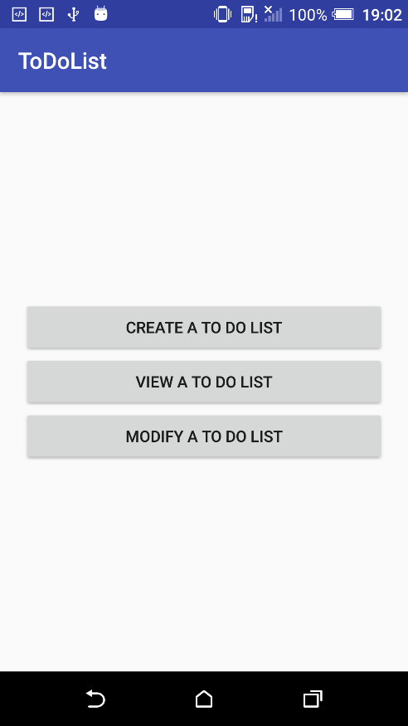 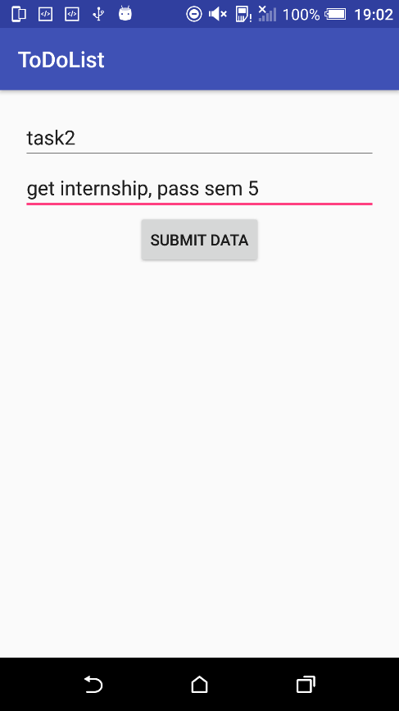

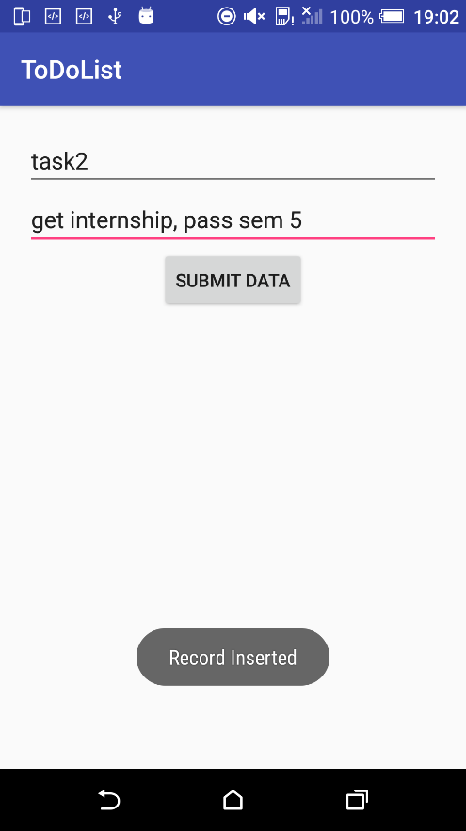 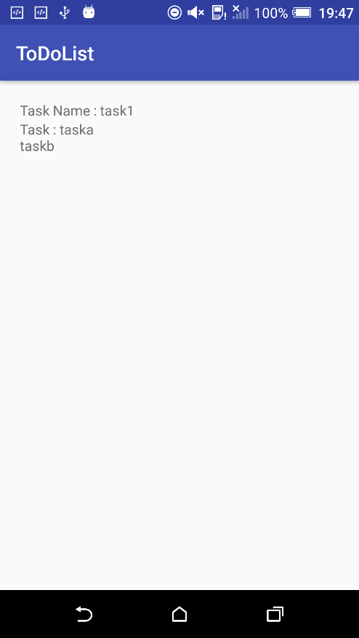

**Practical 13 : Create basic contacts application which allows insertion / deletion / viewing /**

**modification of contacts with use of Room database persistence.**

**Activity_main.xml**

<?xml version="1.0" encoding="utf-8"?>  
<RelativeLayout xmlns:android="http://schemas.android.com/apk/res/android"  
 xmlns:app="http://schemas.android.com/apk/res-auto"  
 xmlns:tools="http://schemas.android.com/tools"  
 android:layout_width="match_parent"  
 android:layout_height="match_parent"  
 android:padding="20dp"  
 tools:context=".MainActivity">  
  
 <Button  
 android:id="@+id/createContactButton"  
 android:layout_width="match_parent"  
 android:layout_height="wrap_content"  
 android:text="Create Contact"/>  
  
 <Button  
 android:id="@+id/viewContactButton"  
 android:layout_width="match_parent"  
 android:layout_height="wrap_content"  
 android:text="View Contact"  
 android:layout_below="@id/createContactButton"/>  
  
 <Button  
 android:id="@+id/modifyContactButton"  
 android:layout_width="match_parent"  
 android:layout_height="wrap_content"  
 android:text="Modify or Delete Contact"  
 android:layout_below="@id/viewContactButton"/>  
  
  
</RelativeLayout>

**Activity_createcontact.xml**

<?xml version="1.0" encoding="utf-8"?>  
<LinearLayout xmlns:android="http://schemas.android.com/apk/res/android"  
 android:orientation="vertical"  
 android:layout_width="match_parent"  
 android:layout_height="match_parent"  
 android:padding="20dp">  
  
 <EditText  
 android:id="@+id/nameEditText"  
 android:layout_width="match_parent"  
 android:layout_height="wrap_content"  
 android:hint="Enter the name"/>  
  
 <EditText  
 android:id="@+id/mobileNumEditText"  
 android:layout_width="match_parent"  
 android:layout_height="wrap_content"  
 android:hint="Enter the mobile number"/>  
  
 <Button  
 android:id="@+id/insertButton"  
 android:layout_width="match_parent"  
 android:layout_height="wrap_content"  
 android:text="Submit"  
 android:layout_gravity="center_horizontal"/>  
  
</LinearLayout>

**Activity_modify.xml**

<?xml version="1.0" encoding="utf-8"?>  
<LinearLayout xmlns:android="http://schemas.android.com/apk/res/android"  
 android:orientation="vertical"  
 android:layout_width="match_parent"  
 android:layout_height="match_parent"  
 android:padding="20dp">  
  
 <EditText  
 android:id="@+id/nameEditText"  
 android:layout_width="match_parent"  
 android:layout_height="wrap_content"  
 android:hint="Enter the name"/>  
  
 <EditText  
 android:id="@+id/mobileNumEditText"  
 android:layout_width="match_parent"  
 android:layout_height="wrap_content"  
 android:hint="Enter the mobile number"/>  
  
 <Button  
 android:id="@+id/insertButton"  
 android:layout_width="match_parent"  
 android:layout_height="wrap_content"  
 android:text="Submit"  
 android:layout_gravity="center_horizontal"/>  
  
</LinearLayout>

**Activity_view.xml**

<?xml version="1.0" encoding="utf-8"?>  
<FrameLayout  
 xmlns:android="http://schemas.android.com/apk/res/android" android:layout_width="match_parent"  
 android:layout_height="match_parent"  
 android:padding="20dp">  
  
 <android.support.v7.widget.RecyclerView  
 android:id="@+id/viewContacts"  
 android:layout_width="match_parent"  
 android:layout_height="match_parent"></android.support.v7.widget.RecyclerView>  
  
</FrameLayout>

**View_contact.xml**

<?xml version="1.0" encoding="utf-8"?>  
<LinearLayout xmlns:android="http://schemas.android.com/apk/res/android"  
 android:orientation="vertical" android:layout_width="match_parent"  
 android:layout_height="match_parent"  
 android:padding="20dp">  
  
 <TextView  
 android:id="@+id/contactNameTextView"  
 android:layout_width="match_parent"  
 android:layout_height="wrap_content" />  
  
 <TextView  
 android:id="@+id/contactMobNumTextView"  
 android:layout_width="match_parent"  
 android:layout_height="wrap_content" />  
  
</LinearLayout>

**Contact.java**

package contact.com.contact;  
import android.arch.persistence.room.Entity;  
import android.arch.persistence.room.PrimaryKey;  
@Entity(tableName = "conatcts")  
public class Contact {  
 @PrimaryKey(autoGenerate = true)  
 private int _id;  
 private String name;  
 private long mobile_number;  
  
 public int get_id() {  
 return _id;  
 }  
  
 public void set_id(int _id) {  
 this._id = _id;  
 }  
  
 public String getName() {  
 return name;  
 }  
  
 public void setName(String name) {  
 this.name = name;  
 }  
  
 public long getMobile_number() {  
 return mobile_number;  
 }  
  
 public void setMobile_number(long mobile_number) {  
 this.mobile_number = mobile_number;  
 }  
}

**ContactDao.java**

package contact.com.contact;  
import android.arch.persistence.room.Dao;  
import android.arch.persistence.room.Delete;  
import android.arch.persistence.room.Insert;  
import android.arch.persistence.room.Query;  
import android.arch.persistence.room.Update;  
import java.util.List;  
  
@Dao  
public interface ContactDao {  
  
 @Query("Select * from conatcts")  
 List<Contact> getAllConatcts();  
  
 @Query("Select * from conatcts where mobile_number = :num")  
 Contact getToDoListByTitle(Long num);  
  
 @Insert  
 void insertContact(Contact... contacts);  
  
 @Update  
 void updateContact(Contact contact);  
 @Delete  
 void deleteContact(Contact contact);  
  
}

**ContactDatabase.java**

package contact.com.contact;  
import android.arch.persistence.room.Database;  
import android.arch.persistence.room.RoomDatabase;  
@Database(entities = {Contact.class}, version = 1)  
public abstract class ContactDatabase extends RoomDatabase {  
 public abstract ContactDao contactDao();  
}

**ContactAdapter.java**

package contact.com.contact;  
import android.content.Context;  
import android.support.annotation.NonNull;  
import android.support.v7.widget.RecyclerView;  
import android.view.LayoutInflater;  
import android.view.View;  
import android.view.ViewGroup;  
import android.widget.TextView;  
import java.util.List;  
public class ContactAdapter extends RecyclerView.Adapter<ContactAdapter.ViewHolder> {  
 private List<Contact> contacts;  
 public ContactAdapter(List<Contact> contacts) {  
 this.contacts = contacts;  
 }  
  
 @NonNull  
 @Override  
 public ViewHolder onCreateViewHolder(@NonNull ViewGroup parent, int viewType) {  
 Context context = parent.getContext();  
 LayoutInflater inflater = LayoutInflater.from(context);  
 View contactView = inflater.inflate(R.layout.view_contact, parent,false);  
  
 return new ViewHolder(contactView);  
 }  
  
 @Override  
 public void onBindViewHolder(@NonNull ViewHolder holder, int position) {  
 Contact contact = contacts.get(position);  
 holder.contactNameTextView.setText("Name : "+contact.getName());  
 holder.contactMobNumTextView.setText("Number : "+contact.getMobile_number());  
 }  
 @Override  
 public int getItemCount() {  
 return contacts.size();  
 }  
  
 public class ViewHolder extends RecyclerView.ViewHolder{  
 public TextView contactNameTextView;  
 public TextView contactMobNumTextView;  
 public ViewHolder(View itemView) {  
 super(itemView);  
  
 contactNameTextView = itemView.findViewById(R.id.contactNameTextView);  
 contactMobNumTextView = itemView.findViewById(R.id.contactMobNumTextView);  
  
 }  
 }  
}

**MainActivity.java**

package contact.com.contact;  
import android.content.Intent;  
import android.support.v7.app.AppCompatActivity;  
import android.os.Bundle;  
import android.view.View;  
import android.widget.Button;  
public class MainActivity extends AppCompatActivity {  
 private Button createContactButton;  
 private Button viewContactButton;  
 private Button modifyContactButton;  
 @Override  
 protected void onCreate(Bundle savedInstanceState) {  
 super.onCreate(savedInstanceState);  
 setContentView(R.layout.activity_main);  
 createContactButton = findViewById(R.id.createContactButton);  
 viewContactButton = findViewById(R.id.viewContactButton);  
 modifyContactButton = findViewById(R.id.modifyContactButton);  
 createContactButton.setOnClickListener(new View.OnClickListener() {  
 @Override  
 public void onClick(View view) {  
 Intent intent = new Intent(MainActivity.this, CreateContactActivity.class);  
 startActivity(intent);  
 }  
 });  
 viewContactButton.setOnClickListener(new View.OnClickListener() {  
 @Override  
 public void onClick(View view) {  
 Intent intent = new Intent(MainActivity.this, ViewContactActivity.class);  
 startActivity(intent);  
 }  
 });  
 modifyContactButton.setOnClickListener(new View.OnClickListener() {  
 @Override  
 public void onClick(View view) {  
 Intent intent = new Intent(MainActivity.this, ModifyDeleteActivity.class);  
 startActivity(intent);  
 }  
 });  
  
 }  
}

**ModifyActivity.java**

package contact.com.contact;  
import android.arch.persistence.room.Room;  
import android.os.Bundle;  
import android.support.annotation.Nullable;  
import android.support.v7.app.AppCompatActivity;  
import android.view.View;  
import android.widget.Button;  
import android.widget.EditText;  
  
public class ModifyDeleteActivity extends AppCompatActivity {  
 private EditText nameEditText;  
 private EditText mobileNumEditText;  
 private Button updateButton;  
 private Button deleteButton;  
 private ContactDatabase contactDatabase;  
  
 @Override  
 protected void onCreate(@Nullable Bundle savedInstanceState) {  
 super.onCreate(savedInstanceState);  
 setContentView(R.layout.activity_modify);  
  
 nameEditText = findViewById(R.id.nameEditText);  
 mobileNumEditText = findViewById(R.id.mobileNumEditText);  
 updateButton = findViewById(R.id.updateButton);  
 deleteButton = findViewById(R.id.deleteButton);  
  
 contactDatabase = Room.databaseBuilder(this, ContactDatabase.class,"Contact_db").allowMainThreadQueries().build();  
  
  
 updateButton.setOnClickListener(new View.OnClickListener() {  
 @Override  
 public void onClick(View view) {  
 Contact contact = new Contact();  
 contact.setName(nameEditText.getText().toString());  
 contact.setMobile_number(Long.parseLong(mobileNumEditText.getText().toString()));  
 contactDatabase.contactDao().updateContact(contact);  
 }  
 });  
  
 deleteButton.setOnClickListener(new View.OnClickListener() {  
 @Override  
 public void onClick(View view) {  
 Contact contact = new Contact();  
 contact.setName(nameEditText.getText().toString());  
 contact.setMobile_number(Long.parseLong(mobileNumEditText.getText().toString()));  
 contactDatabase.contactDao().deleteContact(contact);  
 }  
 });  
  
 }  
}

**ViewActivity.java**

package contact.com.contact;  
import android.arch.persistence.room.Room;  
import android.os.Bundle;  
import android.support.annotation.Nullable;  
import android.support.v7.app.AppCompatActivity;  
import android.support.v7.widget.DefaultItemAnimator;  
import android.support.v7.widget.LinearLayoutManager;  
import android.support.v7.widget.RecyclerView;  
import java.util.List;  
  
public class ViewContactActivity extends AppCompatActivity {  
  
 private ContactDatabase contactDatabase;  
 private RecyclerView recyclerView;  
 private List<Contact> contactList;  
  
 @Override  
 protected void onCreate(@Nullable Bundle savedInstanceState) {  
 super.onCreate(savedInstanceState);  
 setContentView(R.layout.activity_view);  
 recyclerView = findViewById(R.id.viewContacts);  
 contactDatabase = Room.databaseBuilder(this,ContactDatabase.class,"Contact_db").allowMainThreadQueries().build();  
 contactList = contactDatabase.contactDao().getAllConatcts();  
 if(contactList != null && contactList.size() > 0){  
 ContactAdapter contactAdapter = new ContactAdapter(contactList);  
 RecyclerView.LayoutManager layoutManager = new LinearLayoutManager(ViewContactActivity.this);  
 recyclerView.setLayoutManager(layoutManager);  
 recyclerView.setItemAnimator(new DefaultItemAnimator());  
 recyclerView.setAdapter(contactAdapter);  
 }  
 }  
}

**Output:**

